Kubernetes Task-9

- Execute all the steps shown in video.
- Upgrade k8s cluster from 1.26 to 1.28 Version.

Task 1: Execute all the steps shown in video
A) Ingress

What is Ingress in Kubernetes?
Ingress is a Kubernetes API resource that manages external HTTP/HTTPS access to applications running inside the Kubernetes cluster.
Architecture
User / Browser
|
| HTTP/HTTPS
v
+------------------+
| Ingress |
| Traffic Router |
+------------------+
|
| decides where to send
v
+------------------+
| Service |
+------------------+
|
v
+------------------+
| Pod |
| Nginx |
+------------------+

Implementation

Step 1: Check the Kubernetes cluster
Run:
kubectl get nodes
Expected:
NAME STATUS ROLES AGE
k8s-master Ready control-plane ...
k8s-worker1 Ready <none> ...
k8s-worker2 Ready <none> ...
Make sure your nodes are Ready.
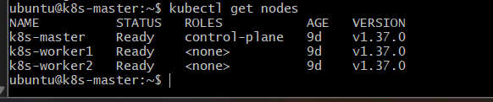

Step 2: Check whether an Ingress Controller exists
Run:
kubectl get pods -A | grep -i ingress
Also:
kubectl get ingressclass
You may see something like:
NAME CONTROLLER PARAMETERS AGE
nginx nginx.org/ingress-controller ... ...

Important
Your Ingress.yml creates an Ingress resource, but an Ingress Controller must exist to actually process the request.
If your cluster already has an NGINX Ingress Controller, continue.
If there is no controller, we need to install one before testing the Ingress.
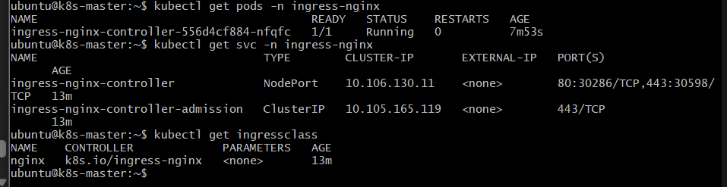

Step 3: Create the Deployment
Create:
vi Deployment.yml

apiVersion: apps/v1
kind: Deployment
metadata:
name: nginx-deployment
spec:
replicas: 1
selector:
matchLabels:
app: nginx
template:
metadata:
labels:
app: nginx
spec:
containers:
- name: nginx
image: nginx:latest
ports:
- containerPort: 80
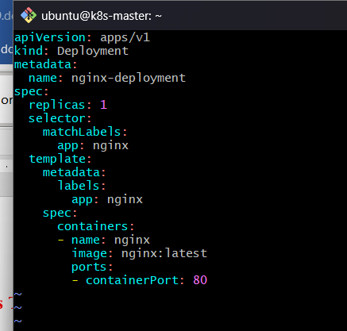
Apply:
kubectl apply -f Deployment.yml
Verify:
kubectl get deployment
kubectl get pods -o wide
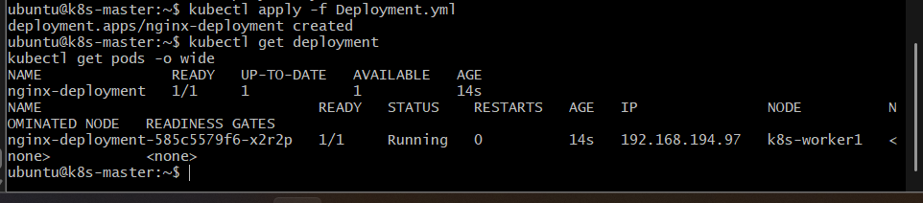
Expected:
NAME READY STATUS RESTARTS AGE
nginx-deployment-xxxxxxxxxx-xxxxx 1/1 Running 0 ...

What happened?
The Deployment created one Nginx Pod.
The Pod has:
label:
app=nginx
That label is important because your Service uses it to identify the Pod.

Step 4: Create the Service
Create:
vi Service.yml

apiVersion: v1
kind: Service
metadata:
name: nginx-service
spec:
selector:
app: nginx
ports:
- protocol: TCP
port: 80
targetPort: 80
nodePort: 30001
type: NodePort
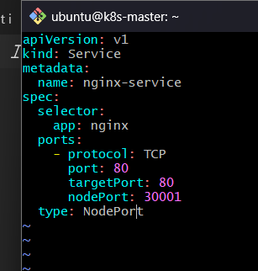
Apply:
kubectl apply -f Service.yml
Verify:
kubectl get svc nginx-service
Expected:
NAME TYPE CLUSTER-IP EXTERNAL-IP PORT(S)
nginx-service NodePort 10.x.x.x <none> 80:30001/TCP
Now check the Service endpoints:
kubectl get endpoints nginx-service
You should see the Pod IP:
NAME ENDPOINTS
nginx-service 192.168.x.x:80
This proves that the Service has successfully discovered the Nginx Pod.
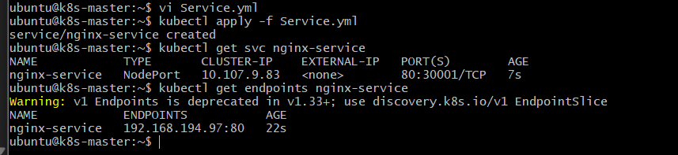

Step 5: Test the Service before Ingress
First verify that the Service itself works.
Get a Pod:
kubectl get pods -o wide
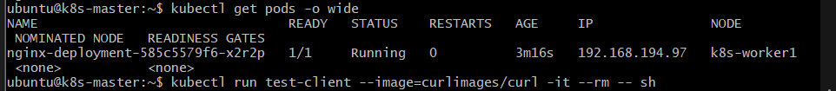
Then from inside the cluster, you can test:
kubectl run test-client --image=curlimages/curl -it --rm -- sh
Inside the temporary Pod:
curl http://nginx-service
Expected:
<!DOCTYPE html>
<html>
<head>
<title>Welcome to nginx!</title>
...
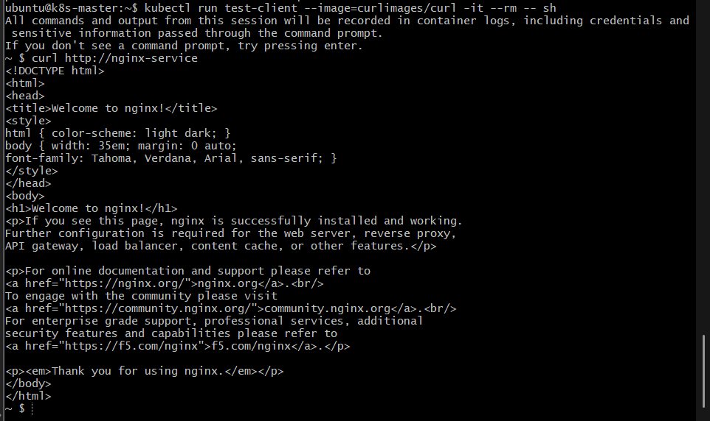
Exit:
exit

Flow so far
test-client
|
| http://nginx-service
v
nginx-service
|
| selector: app=nginx
v
Nginx Pod
|
v
Welcome to nginx!

Step 6: Create the Ingress
Create:
vi Ingress.yml
Use YAML:
apiVersion: networking.k8s.io/v1
kind: Ingress
metadata:
name: nginx-ingress
spec:
rules:
- host: example.com
http:
paths:
- path: /
pathType: Prefix
backend:
service:
name: nginx-service
port:
number: 80
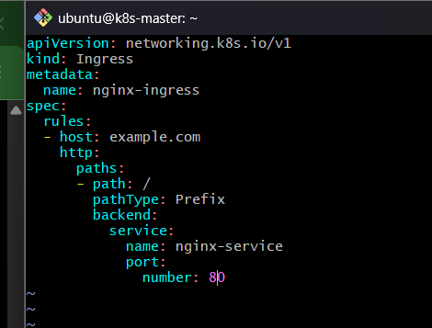
Apply:
kubectl apply -f Ingress.yml
Verify:
kubectl get ingress
Expected:
NAME CLASS HOSTS ADDRESS PORTS
nginx-ingress nginx example.com 80
The exact CLASS and ADDRESS depend on your Ingress Controller.
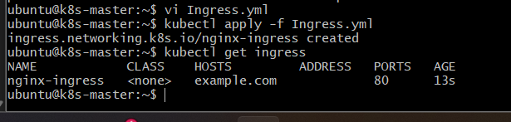

Step 7: Describe the Ingress
Run:
kubectl describe ingress nginx-ingress
Look for:
Rules:
Host Path Backends
---- ---- --------
example.com
/ nginx-service:80
This confirms:
example.com
|
| /
v
nginx-service:80
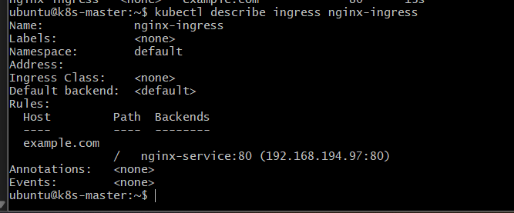

Step 8: Understand the Ingress YAML
Your rule is:
- host: example.com
This means the request must contain:
Host: example.com
Then:
path: /
means requests beginning with / are matched.
For example:
http://example.com/
http://example.com/test
http://example.com/app
Because you used:
pathType: Prefix
the / path can match these paths.
Finally:
backend:
service:
name: nginx-service
port:
number: 80
means the Ingress forwards the request to:
nginx-service:80

Step 9: Find the Ingress Controller address
Run:
kubectl get svc -A | grep -i ingress
Depending on your controller, you may see something like:
ingress-nginx ingress-nginx-controller NodePort ... 80:xxxxx/TCP
or:
ingress-nginx ingress-nginx-controller LoadBalancer ... 80:80/TCP
The exact testing method depends on how your Ingress Controller is exposed.
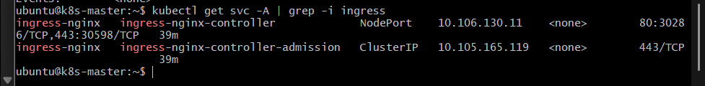

Step 10: Test using the Host header
For learning, you don't necessarily need DNS for example.com.
If you know the IP address through which the Ingress Controller is reachable, test:
curl -H "Host: example.com" http://<INGRESS-IP>/
For example:
curl -H "Host: example.com" http://172.31.x.x/
Expected:
<!DOCTYPE html>
<html>
<head>
<title>Welcome to nginx!</title>
...
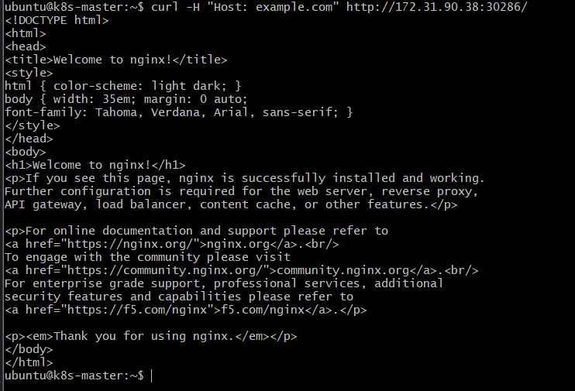
This is an important Ingress test because it verifies that the request contains the correct host:
Host: example.com

Step 11: Optional browser testing
If your Ingress Controller is accessible through an IP address, you can configure your local machine's hosts file.
On Windows:
C:\Windows\System32\drivers\etc\hosts
Add:
<INGRESS-IP> example.com
For example:
172.31.x.x example.com
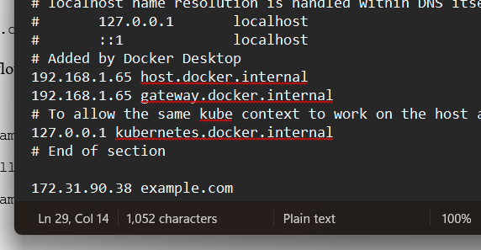

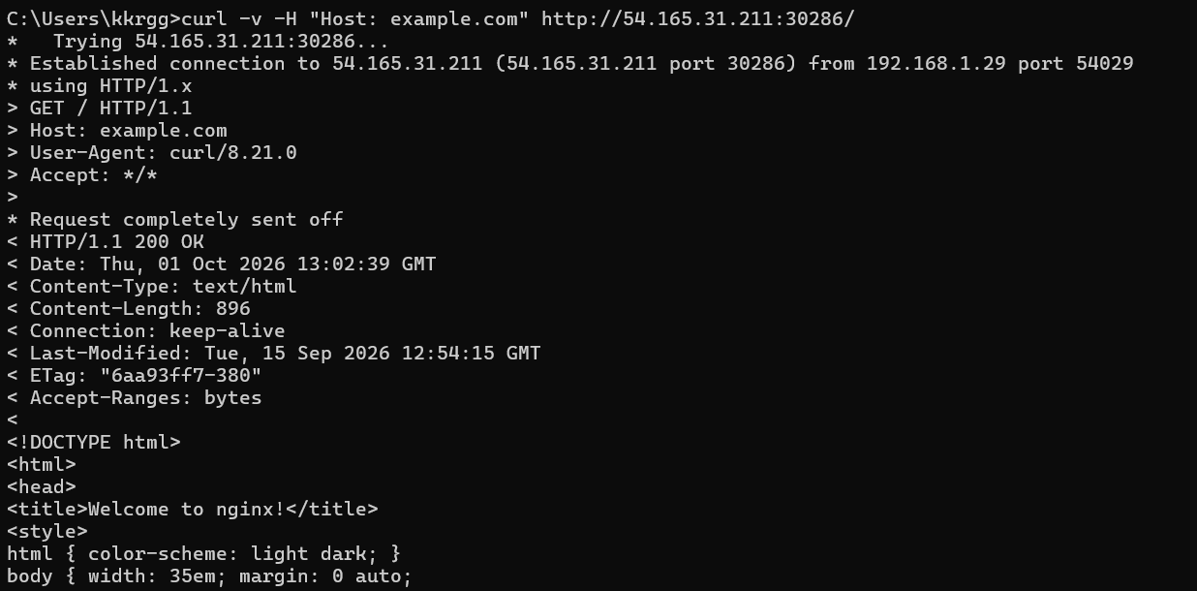
Then open:
http://example.com

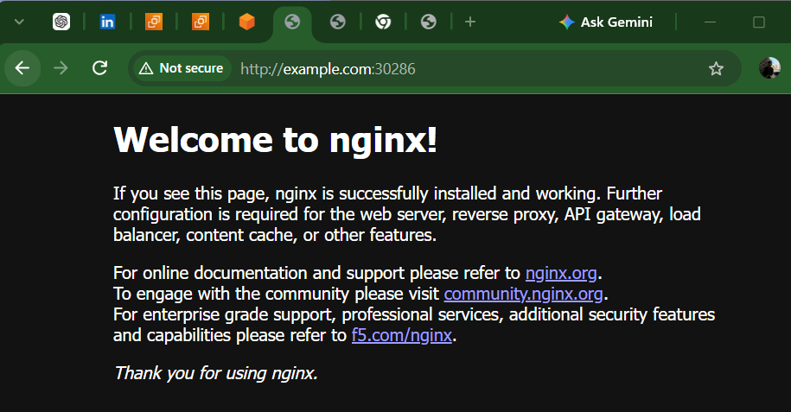
The request will flow:
Browser
|
| http://example.com
v
Ingress Controller
|
| Host = example.com
v
nginx-ingress
|
| nginx-service:80
v
nginx-service
|
| targetPort:80
v
Nginx Pod
|
v
Welcome to nginx!

Step 12: Final Verification
Run:
kubectl get deployment
kubectl get pods -o wide
kubectl get svc
kubectl get endpoints nginx-service
kubectl get ingress
kubectl describe ingress nginx-ingress
You should have:
Deployment
|
v
Nginx Pod
|
| app=nginx
v
nginx-service
|
v
Ingress
|
| Host: example.com
v
Ingress Controller

Outcome
You have created a complete Kubernetes Ingress setup using three YAML files:
File | Kubernetes Resource | Purpose
Deployment.yml | Deployment | Creates Nginx Pod
Service.yml | NodePort Service | Provides access to Nginx Pod
Ingress.yml | Ingress | Routes example.com/ to the Service
B) We can change the Ingress hostname from example.com → nikhil.com.
You need to change it in two places: Kubernetes Ingress and the Windows hosts file.

1. Update Ingress.yml
On k8s-master:
nano Ingress.yml
Change:
host: example.com
to:
host: nikhil.com
Your complete file should be:
apiVersion: networking.k8s.io/v1
kind: Ingress
metadata:
name: nginx-ingress
spec:
ingressClassName: nginx
rules:
- host: nikhil.com
http:
paths:
- path: /
pathType: Prefix
backend:
service:
name: nginx-service
port:
number: 80
Save and exit.
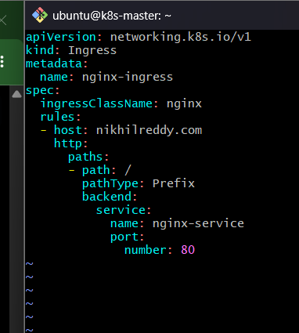

2. Apply the updated Ingress
kubectl apply -f Ingress.yml
Verify:
kubectl get ingress
You should see:
NAME CLASS HOSTS ADDRESS PORTS
nginx-ingress nginx nikhil.com 80
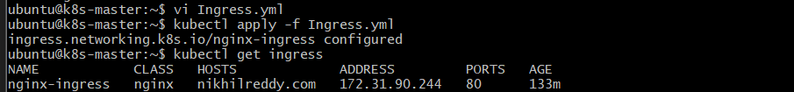

3. Test from k8s-master
Run:
curl -H "Host: nikhil.com" http://172.31.90.38:30286/
You should get:
HTTP/1.1 200 OK
and the nginx welcome page.
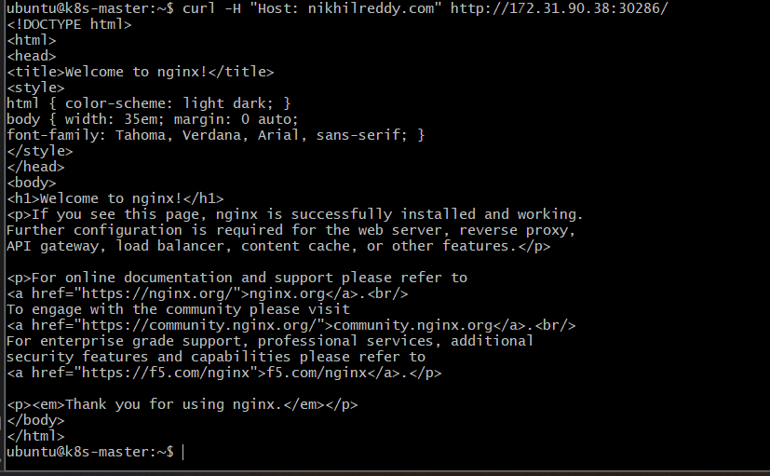

4. Change Windows hosts file
Open Notepad as Administrator and edit:
C:\Windows\System32\drivers\etc\hosts
Change:
54.165.31.211 example.com
to:
54.165.31.211 nikhil.com
Make sure the old example.com entry is removed.
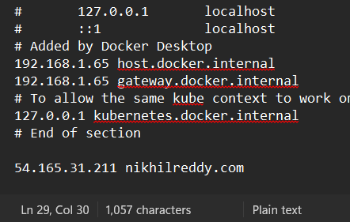

5. Flush DNS cache
Open CMD as Administrator:
ipconfig /flushdns
Then verify:
ping nikhil.com
It should show:
Pinging nikhil.com [54.165.31.211]
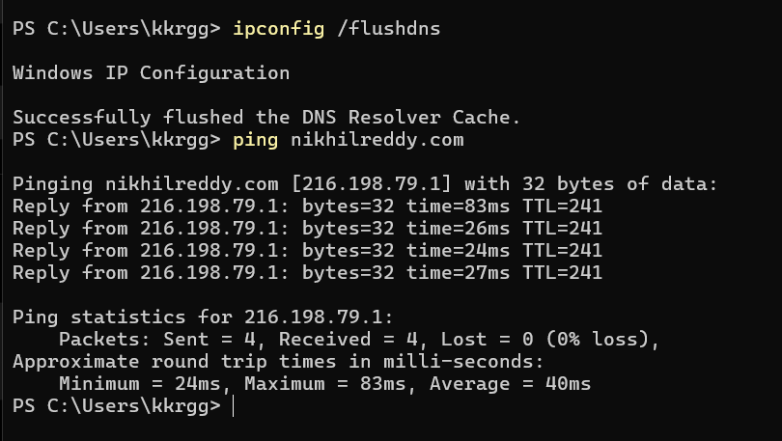

6. Test from Windows CMD
Run:
curl -v http://nikhil.com:30286/
You should get:
HTTP/1.1 200 OK

7. Test in browser
Open:
http://nikhil.com:30286
You should see:
Welcome to nginx! 🎉
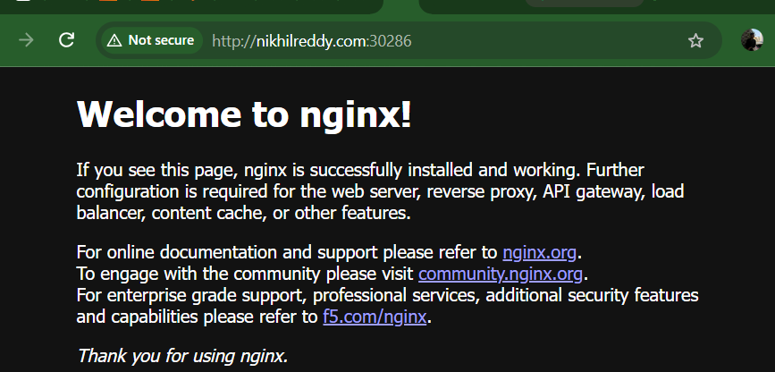

Task 2: Upgrade k8s cluster from 1.26 to 1.28 Version.

Objective
Check the current Kubernetes version and upgrade the kubeadm cluster to the latest supported release, upgrading the control plane first and then workers.

Implementation steps

Step 1 — Check the current cluster version
Run these commands on k8s-master:
kubectl version
Then:
kubectl get nodes -o wide
And:
kubeadm version
Also check:
kubectl get pods -A

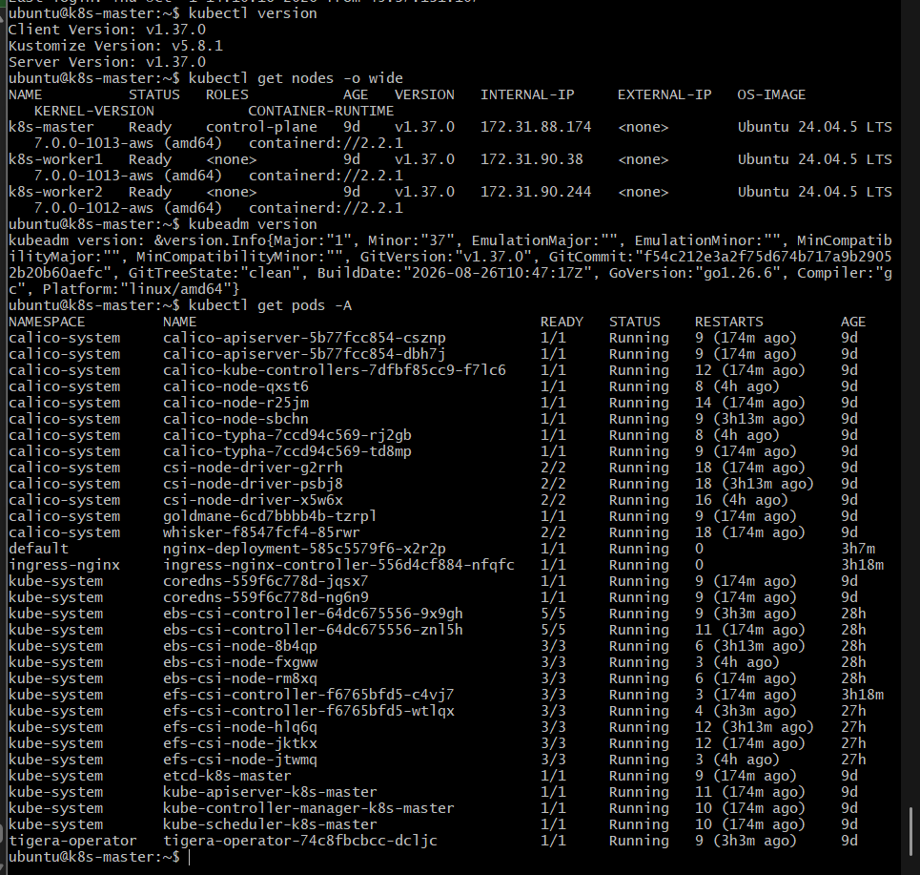

Step 2 — Check versions of all Kubernetes components
On k8s-master:
kubectl get nodes \
-o custom-columns=NAME:.metadata.name,KUBELET:.status.nodeInfo.kubeletVersion
You should get something similar to:
NAME KUBELET
k8s-master v1.37.0
k8s-worker1 v1.37.0
k8s-worker2 v1.37.0

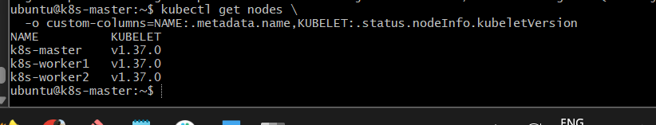

Step 3 — Check available Kubernetes package versions
Because your nodes are Ubuntu, check the kubeadm packages:
sudo apt update
apt-cache madison kubeadm
Also:
apt-cache madison kubelet
This tells us exactly which 1.37.x patch release is available from your configured Kubernetes repository.
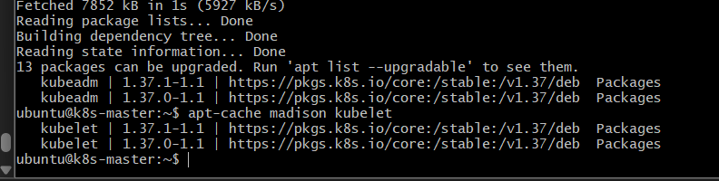

Step 4 — Upgrade kubeadm on k8s-master
Run:
sudo apt-mark unhold kubeadm
sudo apt-get install -y kubeadm=1.37.1-1.1
sudo apt-mark hold kubeadm
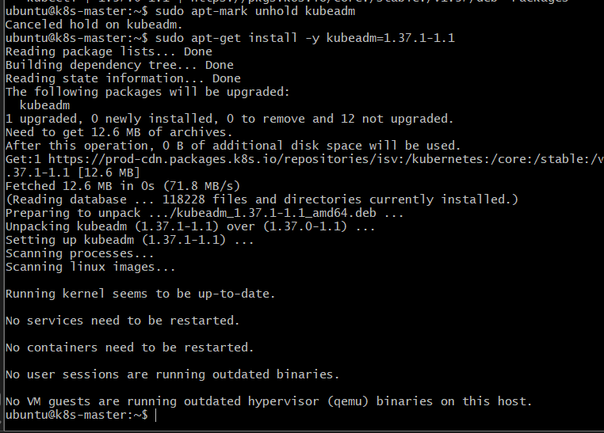
Now verify:
kubeadm version
Expected:
GitVersion:"v1.37.1"
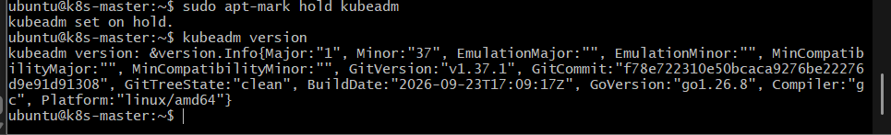

Step 5 — Check the upgrade plan
On k8s-master, run:
sudo kubeadm upgrade plan
This is a check/plan operation; don't run kubeadm upgrade apply yet.
It should identify v1.37.1 as the target and verify that your cluster is upgradeable.

What we expect
Something along these lines:
Upgrade to the latest stable version:

Components that must be upgraded manually after you have upgraded the control plane:
COMPONENT CURRENT TARGET
kubelet v1.37.0 v1.37.1
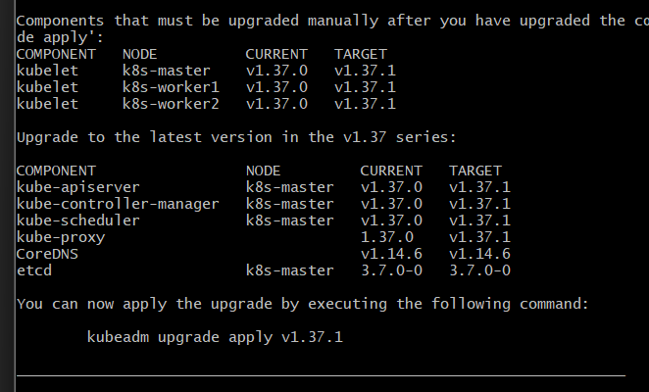

Step 6 — Upgrade the Kubernetes control plane
You are currently on:
k8s-master
Run:
sudo kubeadm upgrade apply v1.37.1

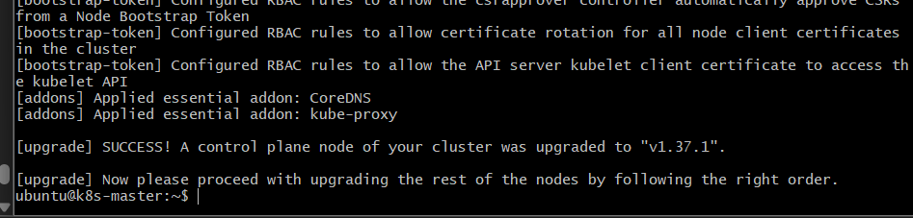

Wait for it to finish.
A successful upgrade should end with something similar to:
[upgrade/successful] SUCCESS!
Your cluster was upgraded to "v1.37.1"
Kubernetes also creates upgrade backups under /etc/kubernetes/tmp during the operation.

Step 7 — Upgrade kubelet and kubectl on k8s-master
Before upgrading them, we should drain the master because the kubelet is being upgraded. Kubernetes recommends draining a node before upgrading its kubelet.

7.1 Drain k8s-master
Run this from the master:
kubectl drain k8s-master --ignore-daemonsets
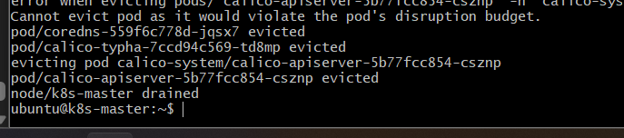
You may see messages about DaemonSet pods being skipped. That is expected because --ignore-daemonsets tells kubectl drain not to evict DaemonSet-managed pods such as Calico and CSI node components.

7.2 Upgrade kubelet and kubectl
After the drain completes:
sudo apt-mark unhold kubelet kubectl
Then:
sudo apt-get install -y kubelet=1.37.1-1.1 kubectl=1.37.1-1.1
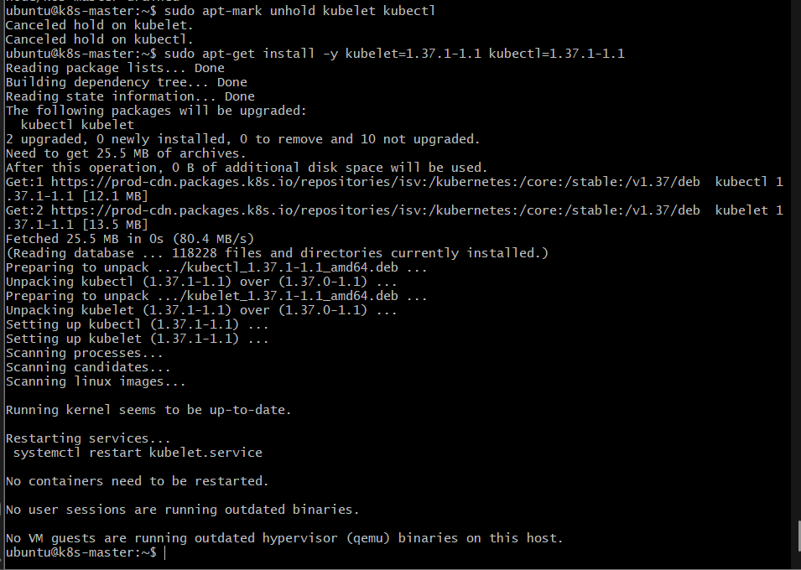
Hold them again:
sudo apt-mark hold kubelet kubectl

7.3 Restart kubelet
sudo systemctl daemon-reload
sudo systemctl restart kubelet
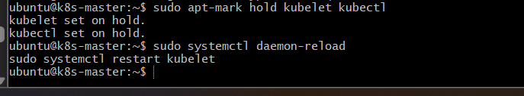
Verify:
kubelet --version
Expected:
Kubernetes v1.37.1
And:
kubectl version
Expected:
Client Version: v1.37.1
Server Version: v1.37.1

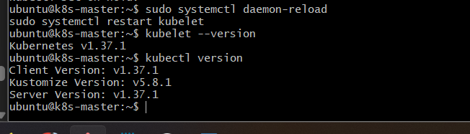

7.4 Uncordon the master
Finally:
kubectl uncordon k8s-master
Then:
kubectl get nodes -o wide
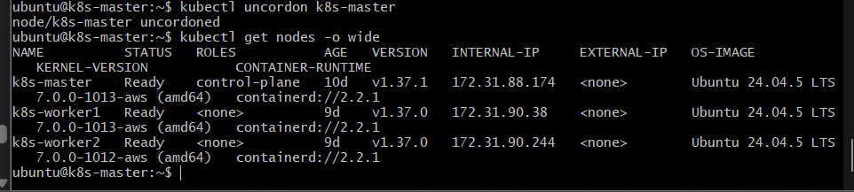
At this point, k8s-master should be Ready and v1.37.1.

Step 8 — Upgrade k8s-worker1
We will now work only on worker1. Do not touch worker2 yet.

Step 8.1 — Upgrade kubeadm on worker1
First SSH into worker1:
ssh ubuntu@54.165.31.211
Then verify you're on the correct node:
hostname
Expected:
k8s-worker1
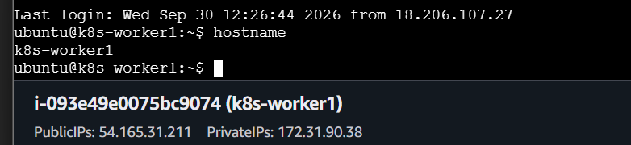
Then check the available kubeadm version:
apt-cache madison kubeadm
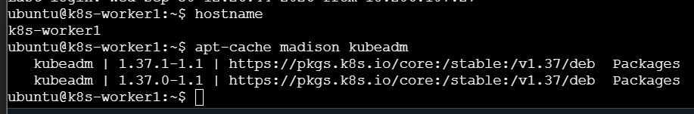
We already know 1.37.1-1.1 is available from the same Kubernetes repository.
Then upgrade kubeadm:
sudo apt-mark unhold kubeadm

sudo apt-get install -y kubeadm=1.37.1-1.1

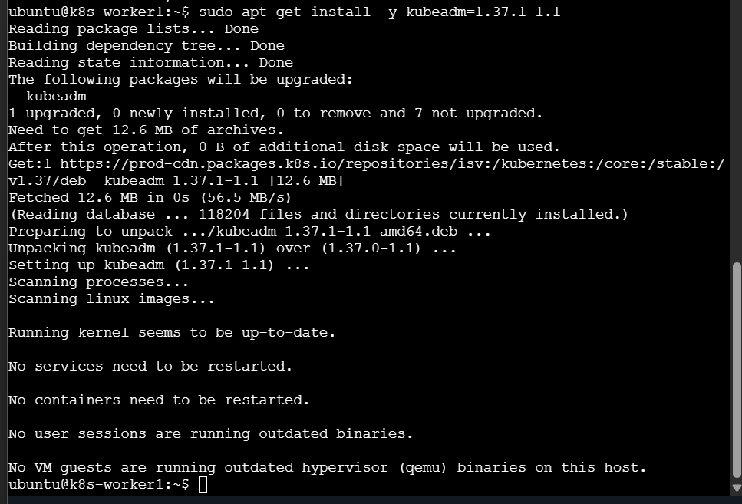
sudo apt-mark hold kubeadm

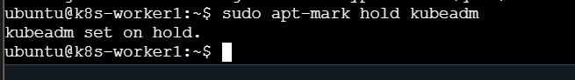
Verify:
kubeadm version
Expected:
GitVersion:"v1.37.1"

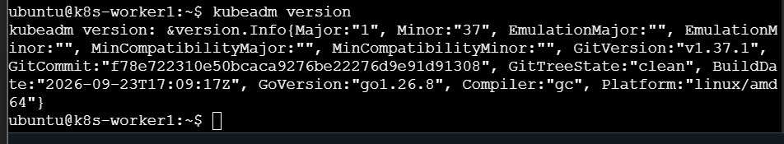

Step 8.2 — Update worker1 kubelet configuration
You are currently on:
k8s-worker1
Run:
sudo kubeadm upgrade node

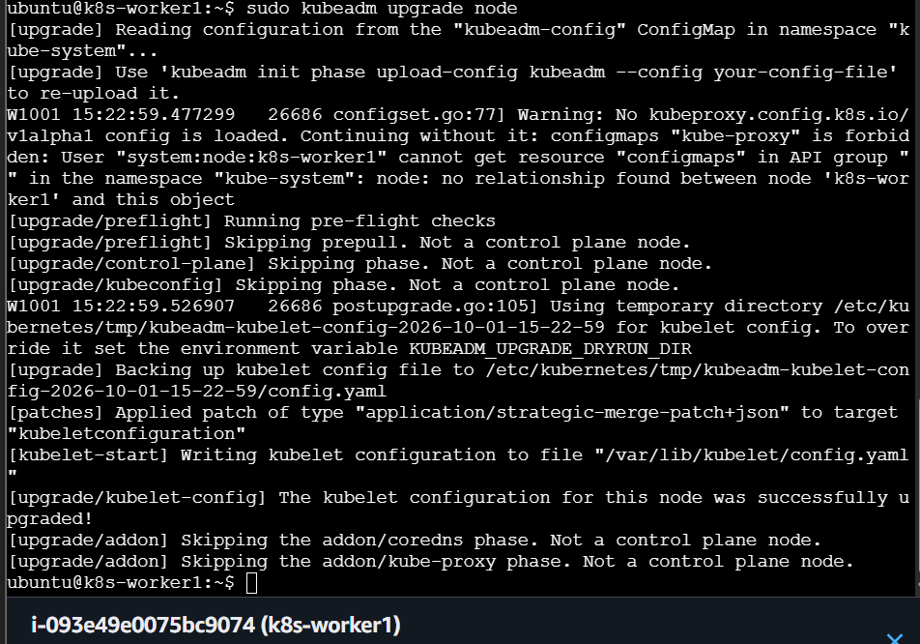

Step 8.3 — Drain k8s-worker1
Now we need to drain worker1 before upgrading its kubelet. Kubernetes recommends draining a worker before its kubelet upgrade.
Important: Run the drain command from k8s-master, because kubectl drain is a cluster-level operation.

8.3.1 — SSH back to master
From worker1:
exit
You should be back at:
ubuntu@k8s-master:~$

8.3.2 — Drain worker1
Run:
kubectl drain k8s-worker1 --ignore-daemonsets --delete-emptydir-data

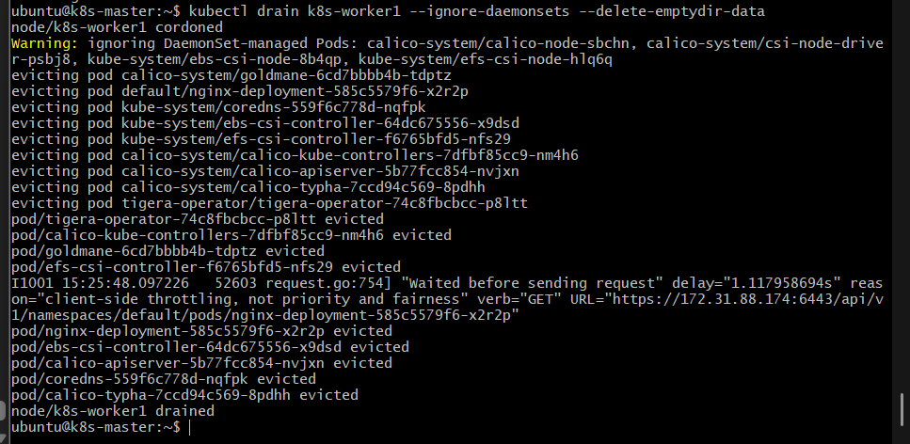

Step 8.4 — Upgrade kubelet on worker1
You are currently on k8s-master.
SSH into worker1:
ssh ubuntu@54.165.31.211
Verify:
hostname
Expected:
k8s-worker1
Then upgrade only the kubelet:
sudo apt-mark unhold kubelet
sudo apt-get install -y kubelet=1.37.1-1.1
Hold it again:
sudo apt-mark hold kubelet

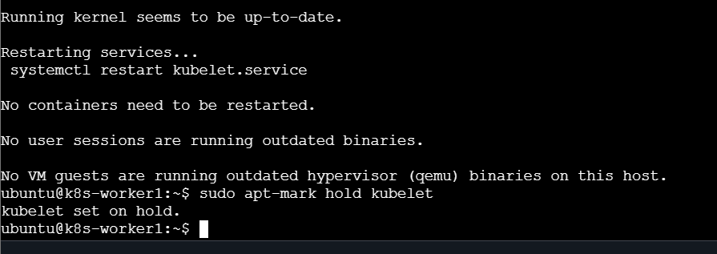
Restart:
sudo systemctl daemon-reload
sudo systemctl restart kubelet
Verify:
kubelet --version
Expected:
Kubernetes v1.37.1

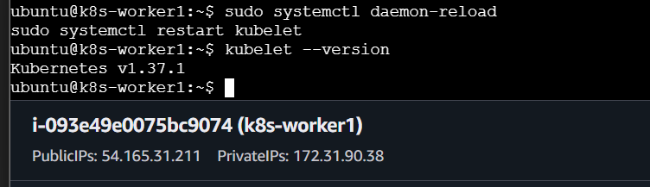

Step 8.5 — Uncordon worker1
You are currently on k8s-worker1.
First, return to the master:
exit
You should see:
ubuntu@k8s-master:~$
Then run:
kubectl uncordon k8s-worker1
Expected:
node/k8s-worker1 uncordoned
Now verify:
kubectl get nodes -o wide
We expect:
NAME STATUS ROLES VERSION
k8s-master Ready control-plane v1.37.1
k8s-worker1 Ready <none> v1.37.1
k8s-worker2 Ready <none> v1.37.0
Then verify that your workloads are healthy:
kubectl get pods -A

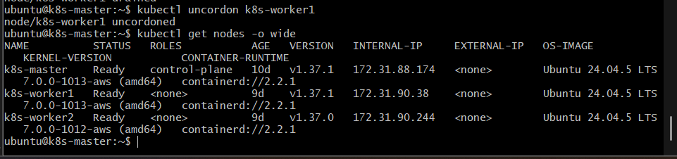
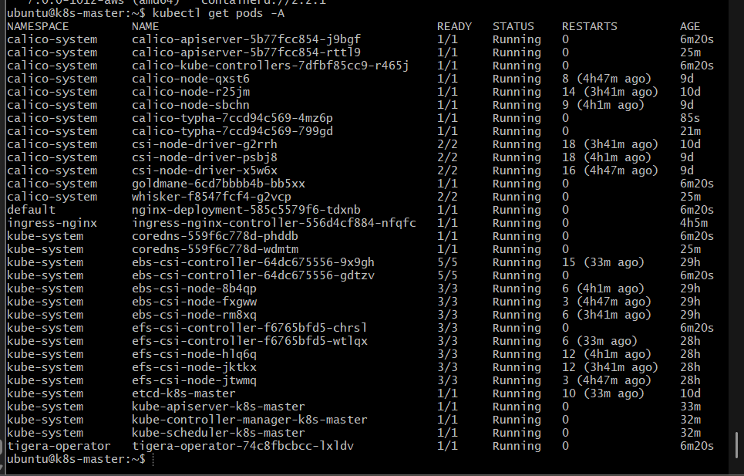

Step 9 — Upgrade k8s-worker2 from v1.37.0 → v1.37.1
Worker1 is upgraded. Now we repeat the worker-node procedure for worker2, one node at a time, which is the Kubernetes-recommended approach.
Current expected state:
k8s-master Ready v1.37.1 ✅
k8s-worker1 Ready v1.37.1 ✅
k8s-worker2 Ready v1.37.0 ← upgrade this

Step 9.1 — SSH to worker2
From k8s-master:
ssh ubuntu@172.31.90.244
Verify:
hostname
Expected:
k8s-worker2
Then:
kubectl version –client

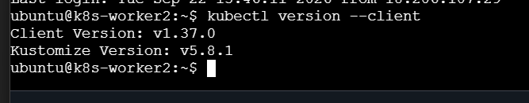
And check kubeadm:
kubeadm version

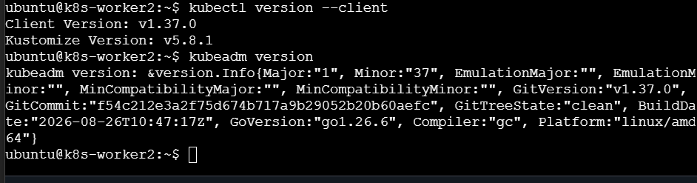

Step 9.2 — Upgrade kubeadm and kubectl
Run on worker2:
sudo apt-mark unhold kubeadm kubectl
sudo apt-get update
sudo apt-get install -y kubeadm=1.37.1-1.1 kubectl=1.37.1-1.1
sudo apt-mark hold kubeadm kubectl

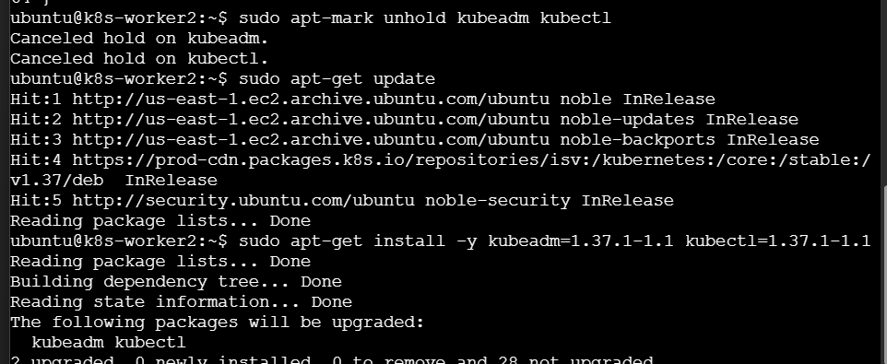

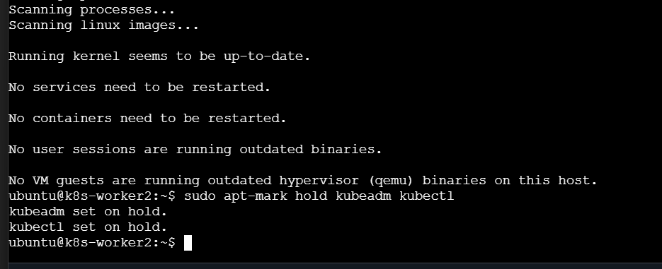
Verify:
kubeadm version
Expected:
GitVersion:"v1.37.1"

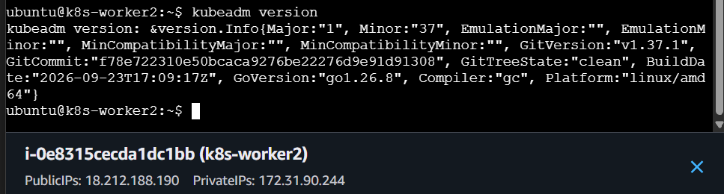
And:
kubectl version --client
Expected:
Client Version: v1.37.1

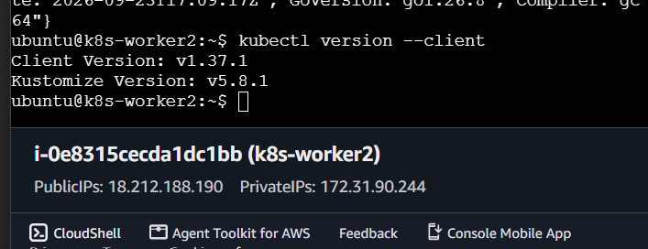
Kubernetes documents upgrading kubeadm and kubectl on a worker before running kubeadm upgrade node.

Step 9.3 — Update worker2 kubelet configuration
Still on k8s-worker2:
sudo kubeadm upgrade node

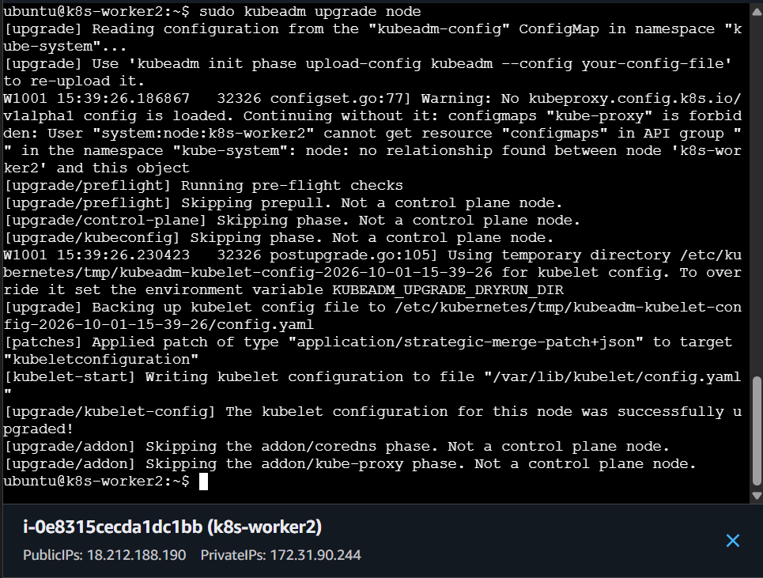

Step 9.4 — Drain k8s-worker2
You are currently on k8s-worker2.
First return to the master:
exit
You should be at:
ubuntu@k8s-master:~$
Now drain worker2:
kubectl drain k8s-worker2 --ignore-daemonsets --delete-emptydir-data

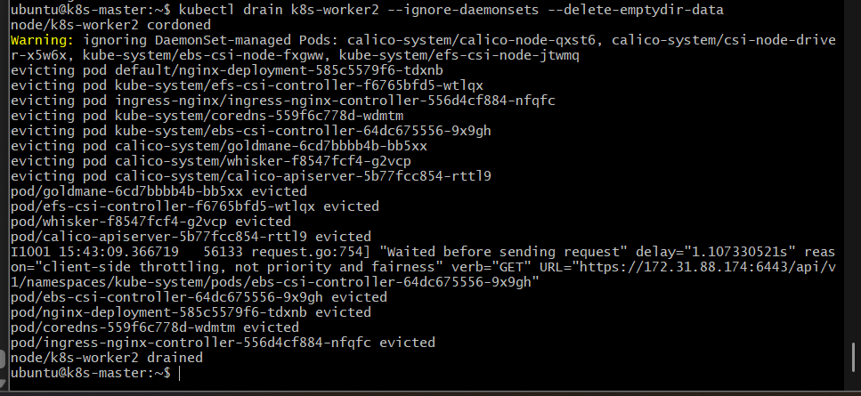

Expected result
You should eventually see:
node/k8s-worker2 cordoned
...
node/k8s-worker2 drained

Step 9.5 — Upgrade kubelet on worker2
Now SSH into worker2:
ssh ubuntu@<worker2-private-ip>
Then run:
sudo apt-mark unhold kubelet
sudo apt-get install -y kubelet=1.37.1-1.1
sudo apt-mark hold kubelet

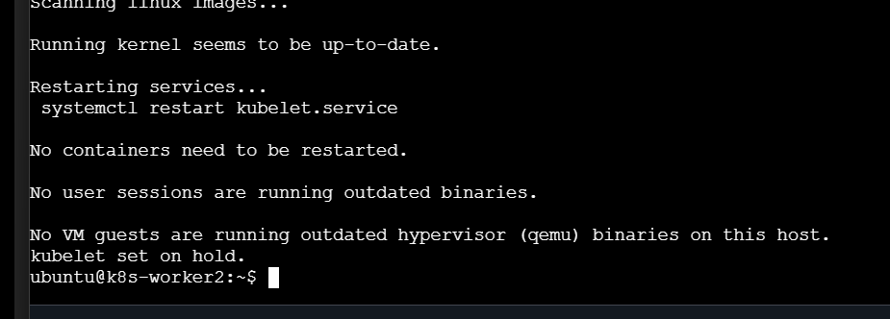
Restart kubelet:
sudo systemctl daemon-reload
sudo systemctl restart kubelet
Verify:
kubelet --version

Expected
Kubernetes v1.37.1

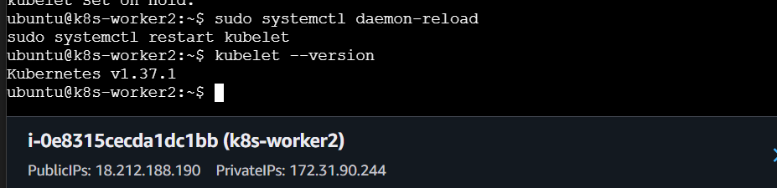

Step 9.6 — Uncordon worker2
You should now be back on the master node.
Run:
kubectl uncordon k8s-worker2
Expected:
node/k8s-worker2 uncordoned
Then verify all nodes:
kubectl get nodes -o wide

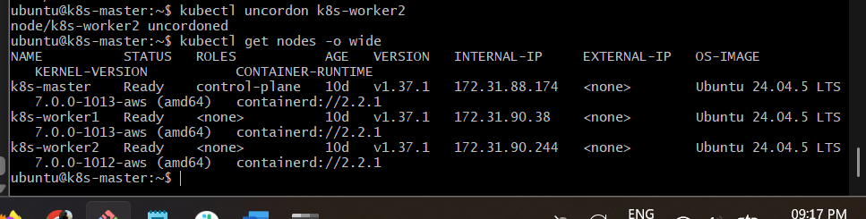

Expected result
All three nodes should be:
NAME STATUS ROLES VERSION
k8s-master Ready control-plane v1.37.1
k8s-worker1 Ready <none> v1.37.1
k8s-worker2 Ready <none> v1.37.1

Step 10 — Final Cluster Upgrade Validation
Now verify the complete cluster from the master.

10.1 Check all node versions and status
kubectl get nodes -o wide
Expected:
NAME STATUS ROLES VERSION
k8s-master Ready control-plane v1.37.1
k8s-worker1 Ready <none> v1.37.1
k8s-worker2 Ready <none> v1.37.1

10.2 Check Kubernetes client/server versions
kubectl version
Both should show:
Client Version: v1.37.1
Server Version: v1.37.1

10.3 Check all pods
kubectl get pods -A

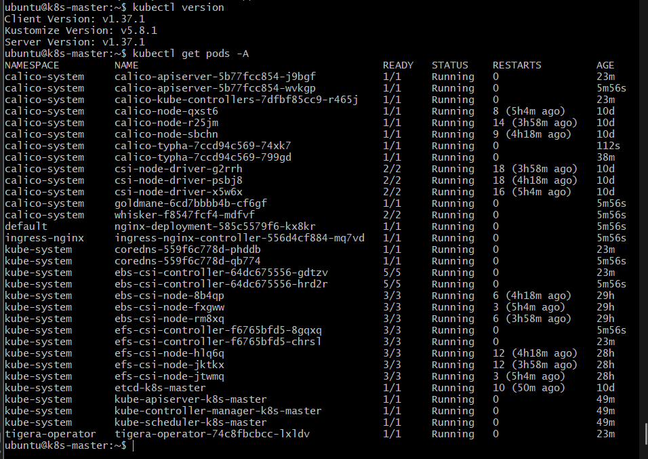

Step 10.4 — Final Node Validation
We still need to confirm that all three nodes are Ready and v1.37.1.
Run:
kubectl get nodes -o wide
Expected:
NAME STATUS ROLES VERSION
k8s-master Ready control-plane v1.37.1
k8s-worker1 Ready <none> v1.37.1
k8s-worker2 Ready <none> v1.37.1
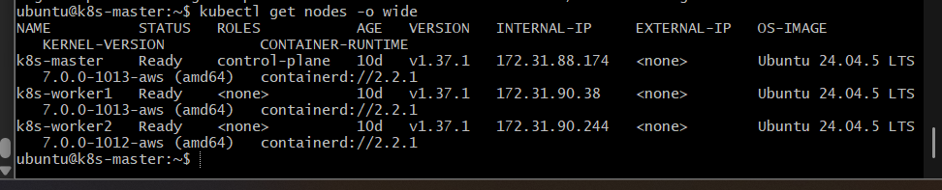

successfully upgraded the cluster to the latest available patch version in our configured v1.37 repository:
Kubernetes v1.37.1

Final architecture
Kubernetes Cluster
v1.37.1
|
┌───────────────┼───────────────┐
↓ ↓ ↓
k8s-master k8s-worker1 k8s-worker2
Ready Ready Ready
v1.37.1 v1.37.1 v1.37.1

